

# Dianna Abney



# Tom Barnett

# 

# Dana Burke

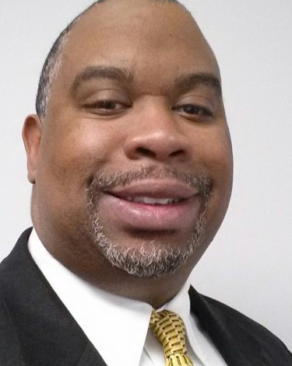 **Kelsey Bush**

# Lindsay Frazier

# Gerald Gardiner, Jr.

# Tom Garrison

# Robert Goodman

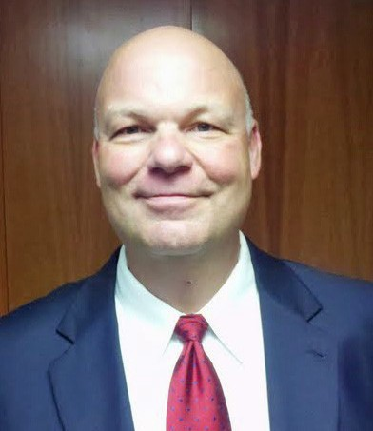

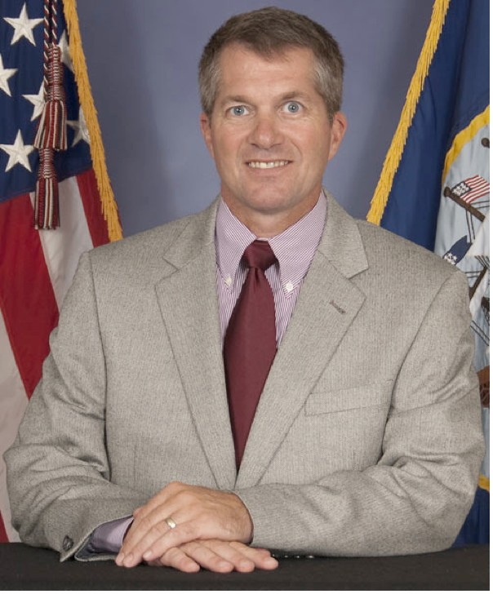 **Tim Gowen**

# Darla Hardy

# Amber Hughes



# Donna Jordan

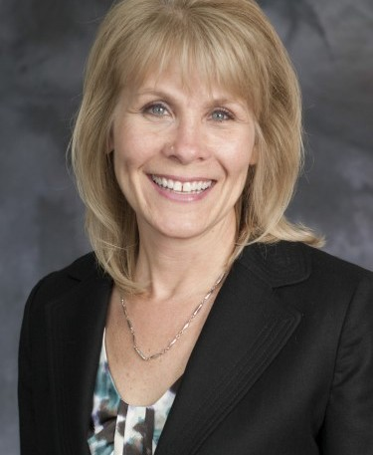 **Dana Levy**

# Kelly McMurray

# Agnes Miller

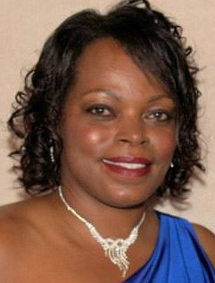

 **Brendan Moon**

**Walt Nilsson**



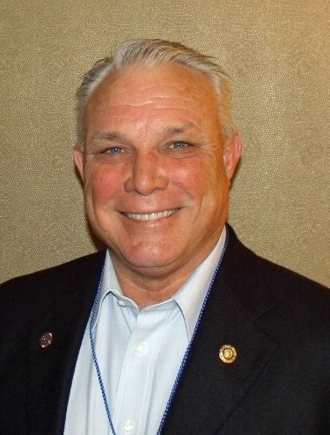 **Dan Parker**

 **Christina Payne**

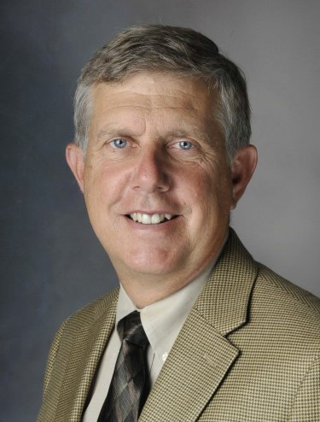

**Tom Phelan**

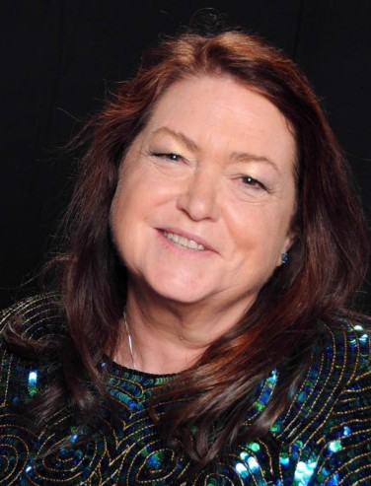 **Anne Powers**

# Chris Powers



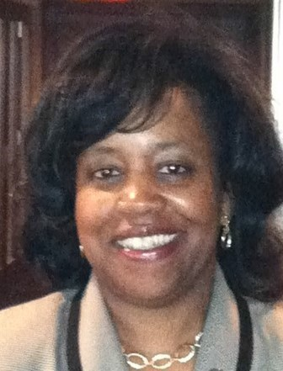 **Sharmella Riggs**

# Nancy Schertler



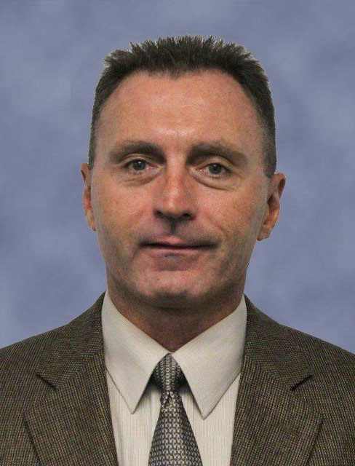 **Fred Severson**



# Julie Simpson

# Karen Smith-Hupp

 **Stephanie Taylor Selvidge**

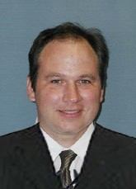 **Mike VanMeter**

# Kristine Wilcox

# Stephanie Witte

 **Lynette Morrissette**