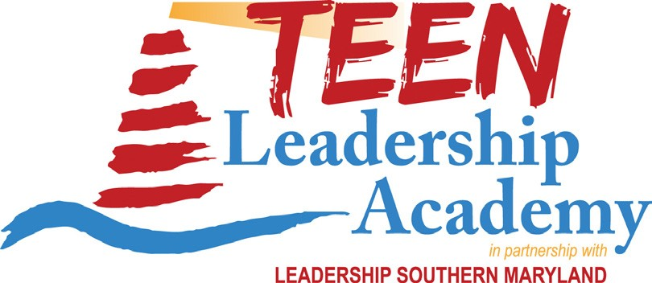 TLA Ambassador Application Checklist

To reserve your space:

Leadership Southern Maryland’s TLA has a first-come, first-served registration process. Your registration is complete when the following submitted materials and fee payment are received by Leadership Southern Maryland:

- A completed TLA Ambassador application (online via www.leadershipsomd.org)
- A signed copy of TLA’s Expectations/Rules
- A signed letter of recommendation completed by an adult or peer who can speak to your leadership abilities and potential. This letter should be mailed to Leadership Southern Maryland, P.O. Box 524, Leonardtown MD 20650 or by email to info@leadershipsomd.org or by fax to 240-725-5402.
- Full payment of $225 made online at www.leadershipsomd.org as part of the online application process or by check payable to Leadership Southern Maryland and mailed to address listed under bullet #3.

Refunds:

In the event that you cancel your registration after June 1, 2017, tuition will NOT be refunded. Questions?
Call the Leadership Southern Maryland office at 240-725-5469 or email info@leadershipsomd.org.

TLA runs from June 26 – 29 at College of Southern Maryland’s Prince Frederick campus.

